**RBAC TESTING DOCUMENT**

## **DATABASE &SCHEMA CREATION**

In the Snowflake Dev environment, created a database named RAW_DEV and created 3 schemas named DEV_RAW_MERAKI,DEV_RAW_MICROSOFTGRAPH,DEV_RAW_SALESFORCE.

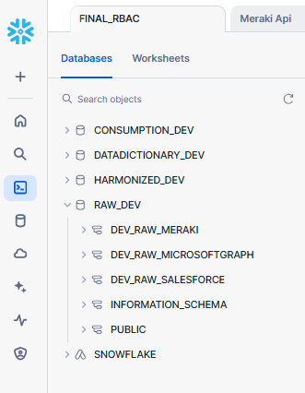

In the Snowflake Dev environment, created a database named HARMONIZED_DEV and created 3 schemas named DEV_HAR_MERAKI,DEV_HAR_MICROSOFTGRAPH,DEV_HAR_SALESFORCE.

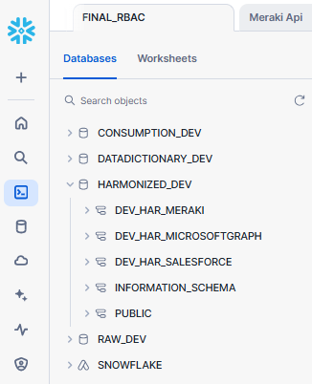

In the Snowflake Dev environment, created a database named CONSUMPTION_DEV and created 2 schemas named DEV_CON_EMPLOYEE_TRACKER,DEV_CON_CUSTOMER_JOURNEY

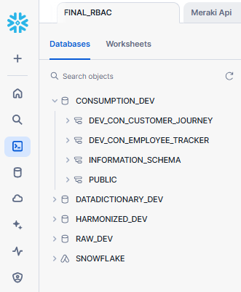

In the Snowflake Dev environment, created a database named DATADICTIONARY_DEV and created a schema named DEV_DICTIONARY.

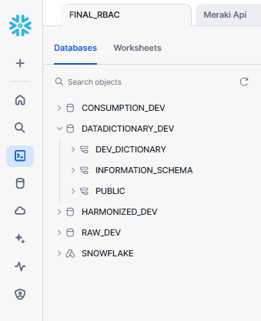

## **ROLE HEIRARCHY**

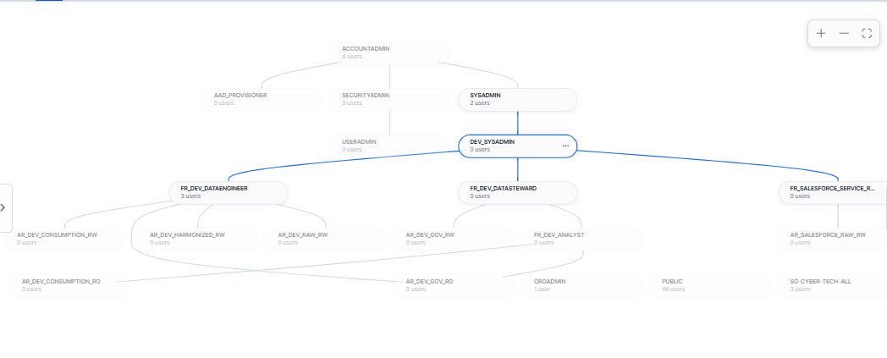

## 

## **OBJECT ACCESS PRIVILEGE TO ROLES**

## **1. FR_SALESFORCE_SERVICE_ROLE :-**

* In the figure below it can be clearly seen that the FR_SALEFORCE_SERVICE_ROLE does not have access to the HARMONIZED_DEV, CONSUMPTION_DEV ,DATADICTIONARY_DEV database but it has access to the RAW_DEV database and it can access only DEV_RAW_SALESFORCE to load data from Salesforce using Sync out connector.

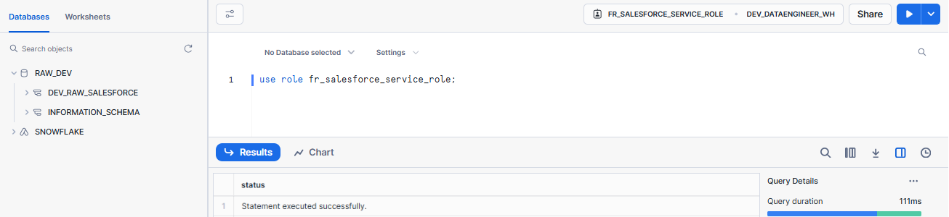

**FR_SALEFORCE_SERVICE_ROLE** has **create table, Select, Insert, Update, Delete, Truncate** privilege on tables and **usage** privilegeson schema DEV_RAW_SALESFORCE as shown in privileges section in below screenshot.

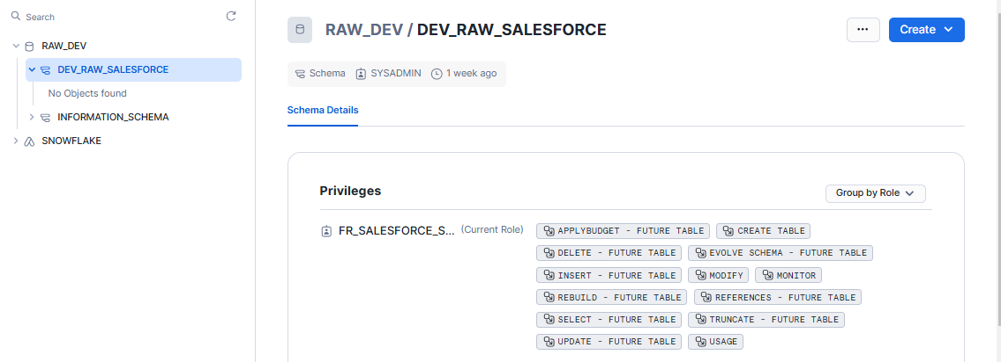

## 2. **FR_DEV_DATAENGINEER** :-

In the figure below it can be clearly seen that the FR_DEV_DATAENGINEER have access to the **RAW_DEV,HARMONIZED_DEV, CONSUMPTION_DEV ,DATADICTIONARY_DEV** database and can able to access **all schemas** in respective databases.

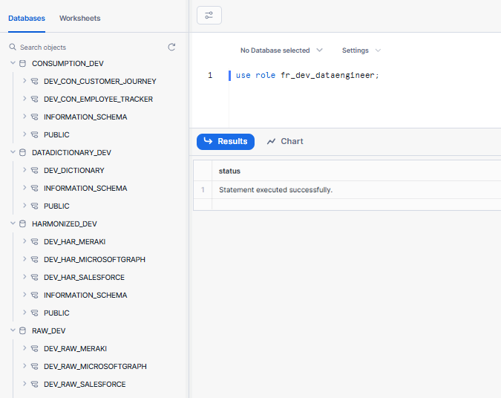

**RAW_DEV DATABASE**

**FR_DEV_DATAENGINEER** has CREATE ALERT,CREATE DYNAMIC TABLE,CREATE EVENT TABLE,CREATE EXTERNAL TABLE,CREATE FILE FORMAT,CREATE FUNCTION,CREATE NOTEBOOK,CREATE PIPE,CREATE PROCEDURE,CREATE SEQUENCE,CREATE STAGE,CREATE STREAM,CREATE TABLE,CREATE TASK,MODIFY,MONITOR,USAGE privileges on **all schemas** in **RAW_DEV** database as shown in privileges section in below screenshot.

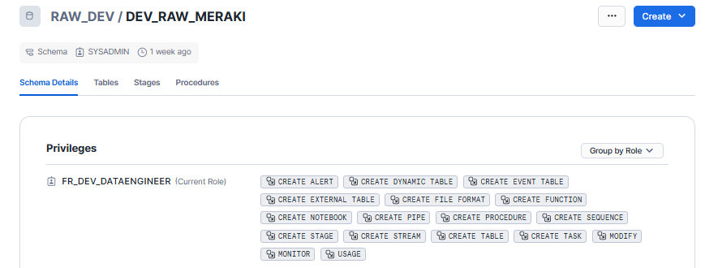

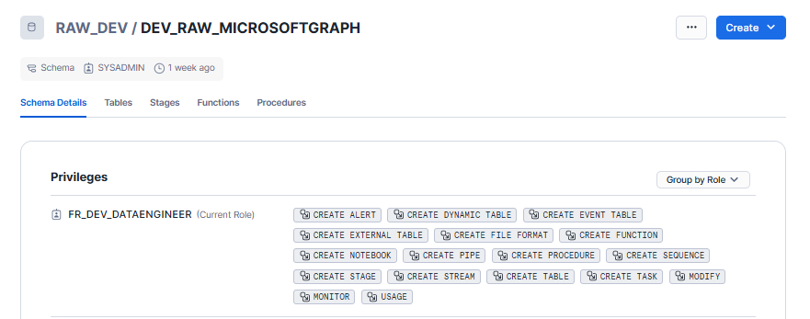

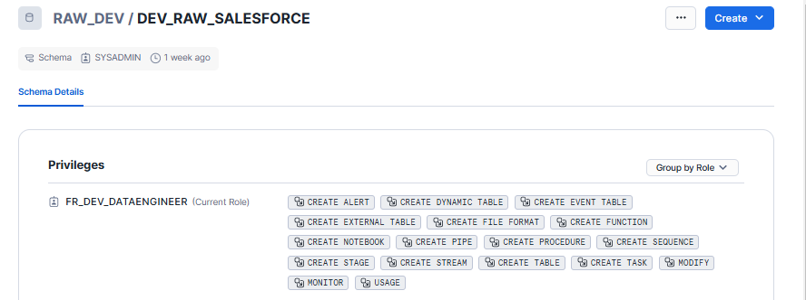

**HARMONIZED_DEV**

**FR_DEV_DATAENGINEER** has ADD SEARCH OPTIMIZATION,CREATE ALERT,CREATE DYNAMIC TABLE,CREATE EVENT TABLE,CREATE EXTERNAL TABLE,CREATE FUNCTION,CREATE MATERIALIZED VIEW,CREATE NOTEBOOK,CREATE PROCEDURE,CREATE SEQUENCE,CREATE STAGE,CREATE STREAM,CREATE TABLE,CREATE TASK,CREATE VIEW,MODIFY,MONITOR,USAGE privileges on **all schemas** in **HARMONIZED_DEV** database as shown in privileges section in below screenshot.

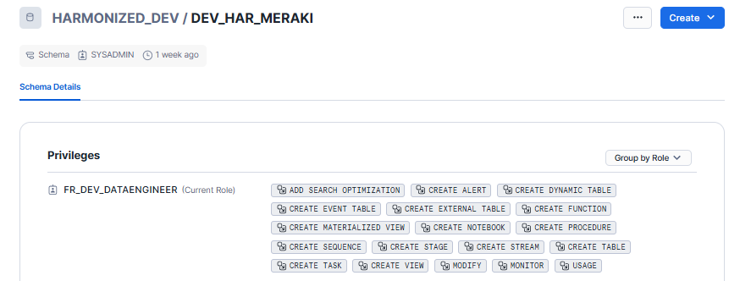

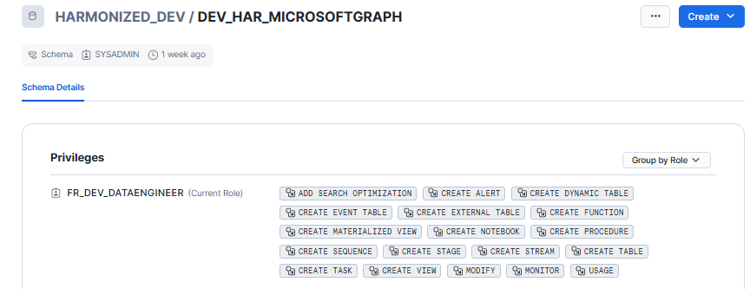

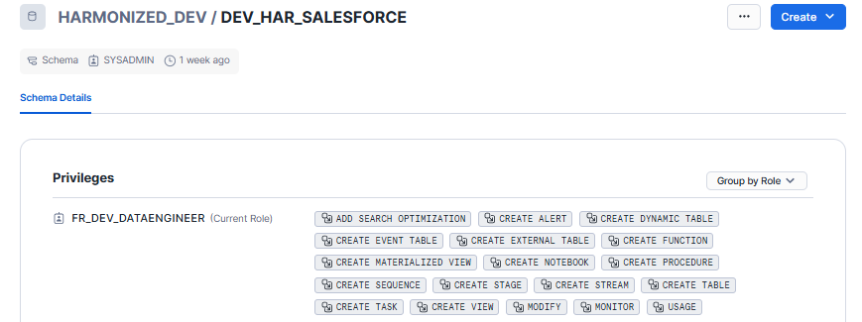

**CONSUMPTION_DEV**

**FR_DEV_DATAENGINEER** has CREATE CORTEX SEARCH SERVICE,CREATE MATERIALIZED VIEW,CREATE TABLE,CREATE VIEW,MODIFY,MONITOR,USAGE privileges on **all schemas** in **CONSUMPTION_DEV** database as shown in privileges section in below screenshot.

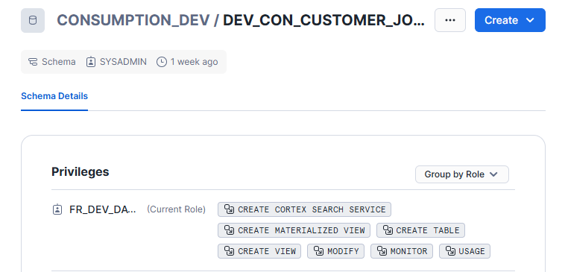

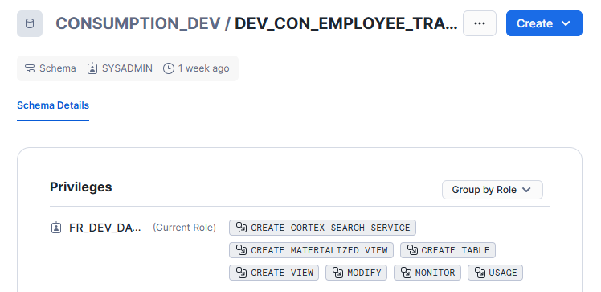

**DATADICTIONARY_DEV**

**FR_DEV_DATAENGINEER** has Usage privilege on **all schemas** in **DATADICTIONARY_DEV** database as shown in privileges section in below screenshot.

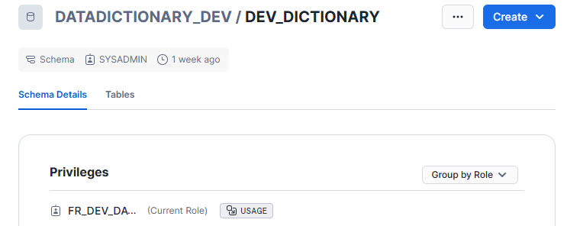

## 3. **FR_DEV_DATASTEWARD** :-

In the figure below it can be clearly seen that the FR_DEV_DATASTEWARD have access to the **RAW_DEV,HARMONIZED_DEV, CONSUMPTION_DEV ,DATADICTIONARY_DEV** database and can able to access **all schemas** in respective databases.

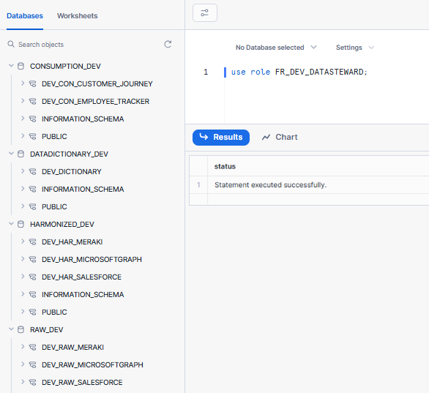

**RAW_DEV DATABASE**

**FR_DEV_DATASTEWARD** has CREATE MASKING POLICY,CREATE PACKAGES POLICY,CREATE ROW ACCESS POLICY,CREATE SESSION POLICY,CREATE TAG,MODIFY,MONITOR,USAGE privileges on **all schemas** in **RAW_DEV** database as shown in privileges section in below screenshot.

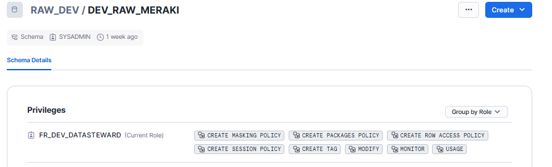

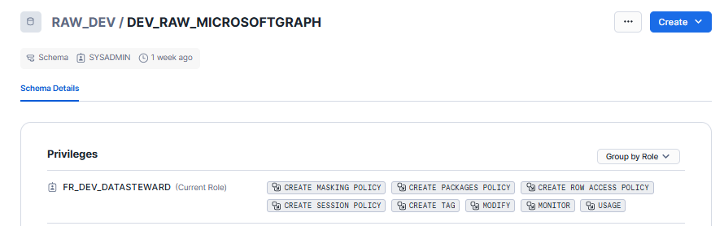

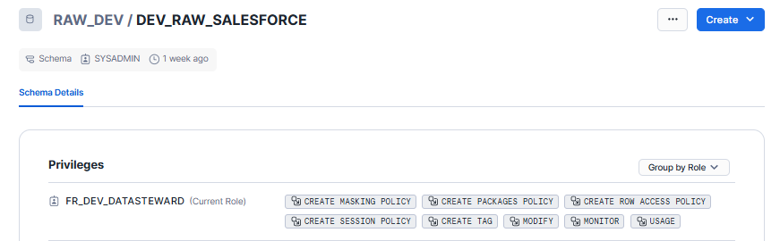

**HARMONIZED_DEV**

**FR_DEV_DATASTEWARD** has CREATE MASKING POLICY,CREATE PACKAGES POLICY,CREATE ROW ACCESS POLICY,CREATE SESSION POLICY,CREATE TAG,MODIFY,MONITOR,USAGE privileges on **all schemas** in HARMONIZED_DEV database as shown in privileges section in below screenshot.

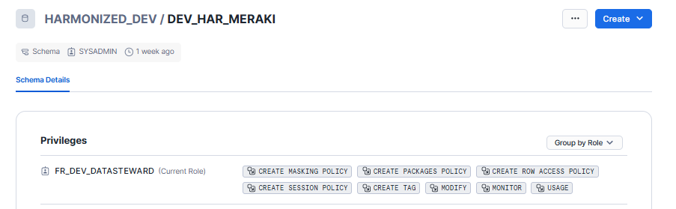

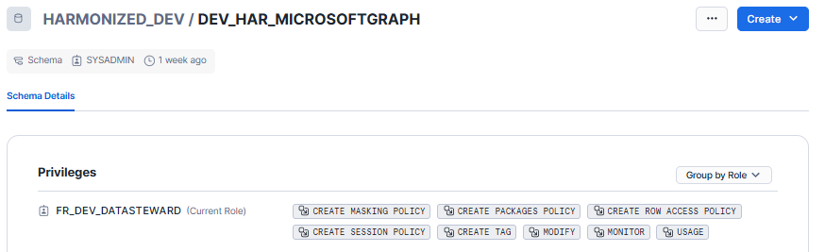

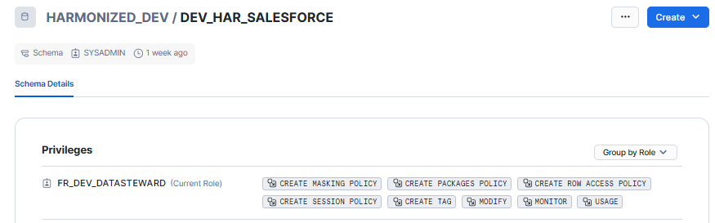

**CONSUMPTION_DEV**

**FR_DEV_DATASTEWARD** has CREATE MASKING POLICY,CREATE PACKAGES POLICY,CREATE ROW ACCESS POLICY,CREATE SESSION POLICY,CREATE TAG,MODIFY,MONITOR,USAGE privileges on **all schemas** in CONSUMPTION_DEV database as shown in privileges section in below screenshot.

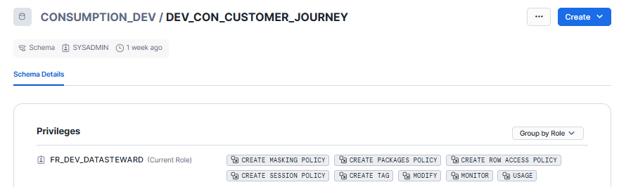

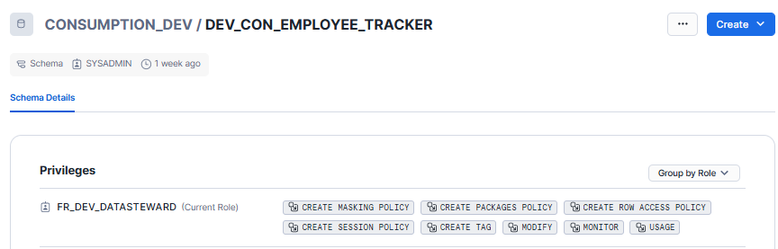

**DATADICTIONARY_DEV**

**FR_DEV_DATASTEWARD** has CREATE TABLE,MODIFY,MONITOR,USAGE privileges on **all schemas** in CONSUMPTION_DEV database as shown in the privileges section in below screenshot.

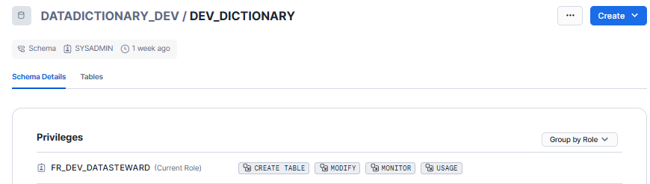

## 4. **FR_DEV_DATA_ANALYST** :-

In the figure below it can be clearly seen that the FR_DEV_DATA_ANALYST have access to the **CONSUMPTION_DEV ,DATADICTIONARY_DEV** database and can able to access **all schemas** in respective databases and not able to access RAW_DEV, HARMONIZED_DEV databases as expected.

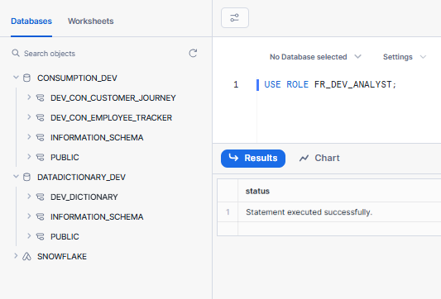

**CONSUMPTION_DEV DATABASE**

**FR_DEV_DATA_ANALYST** has USAGE privileges on **all schemas** in the CONSUMPTION_DEVdatabase as shown in the privileges section in the screenshot below.

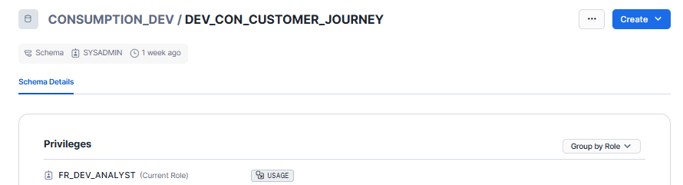

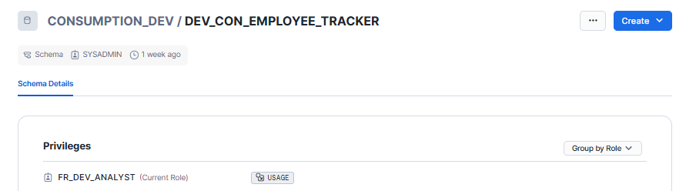

**FR_DEV_DATA_ANALYST** also have SELECT - FUTURE MATERIALIZED VIEW,SELECT - FUTURE TABLE,SELECT - FUTURE VIEW privileges in CONSUMPTION_DEV DB but it can’t insert,update,delete tables in CONSUMPTION_DEV.